**OverTheWire Bandit - Level 7 to Level 8 Writeup**

**Introduction**: This writeup documents my experience solving Levels 7 to 8 of the OverTheWire Bandit challenge, a CTF-style game focused on learning about security concepts.

**Author**: Misha Jain

**Date**: October 19, 2023

**Tools Used:**

Terminal (SSH client)

**Challenge Description:**

Level 7 to Level 8 of Bandit involves connecting to a remote server via SSH and finding a password stored in a file with specific instructions.

**Enumeration:**

For Level 7, we need to connect to the server using the credentials we obtained in Level 6. Our goal is to find a password stored in the file "data.txt" next to the word ‘millionth’.

**Exploitation - Level 7:**

To connect to the server for Level 7 using SSH, we use the provided credentials:

ssh bandit7@bandit.labs.overthewire.org -p 2220

Use the password obtained from Level 6, which is z7WtoNQU2XfjmMtWA8u5rN4vzqu4v99S to gain access.

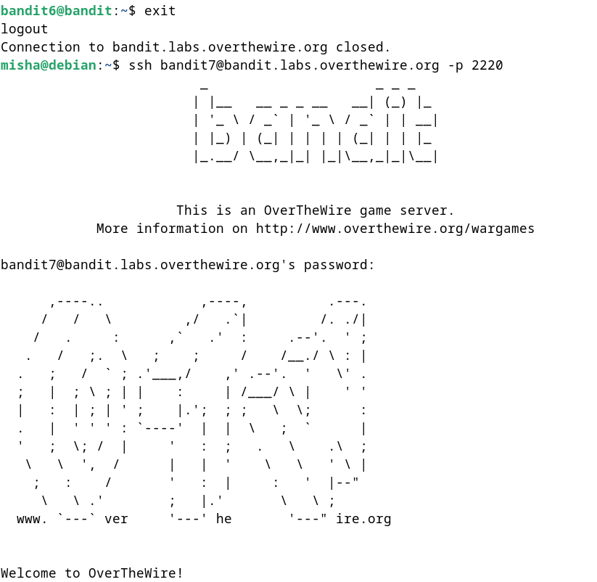

**Password Retrieval - Level 7:**

The password for Level 8 is stored in the file "data.txt" next to the word ‘millionth’. We can see the list of files using the ls command.

ls -alps

To check the contents of the data.txt file, we can use the cat command.

cat data.txt

We can use the grep command to search for and extract the line containing the word ‘millionth’ from the file:

strings data.txt | grep “millionth”

The strings command extracts printable strings from a binary file. In this case, it's reading the contents of "data.txt" and extracting the text strings from it.

The grep command is a text-search utility that searches for a specified pattern or text string in its input. In this case, it's searching for the word "millionth" in the output of the strings command.

These commands will display the Level 8 password.



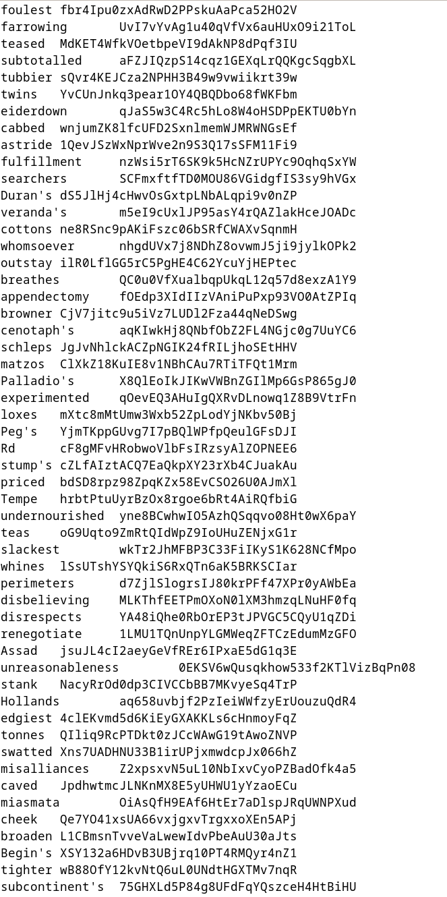



**Password – Level 8:**

The password for Level 8 is: TESKZC0XvTetK0S9xNwm25STk5iWrBvP

**Exploitation – Level 8:**

Now that we have the Level 8 password, we can connect to the server for Level 8 using SSH:

ssh bandit8@bandit.labs.overthewire.org -p 2220

Use the Level 8 password to gain access.

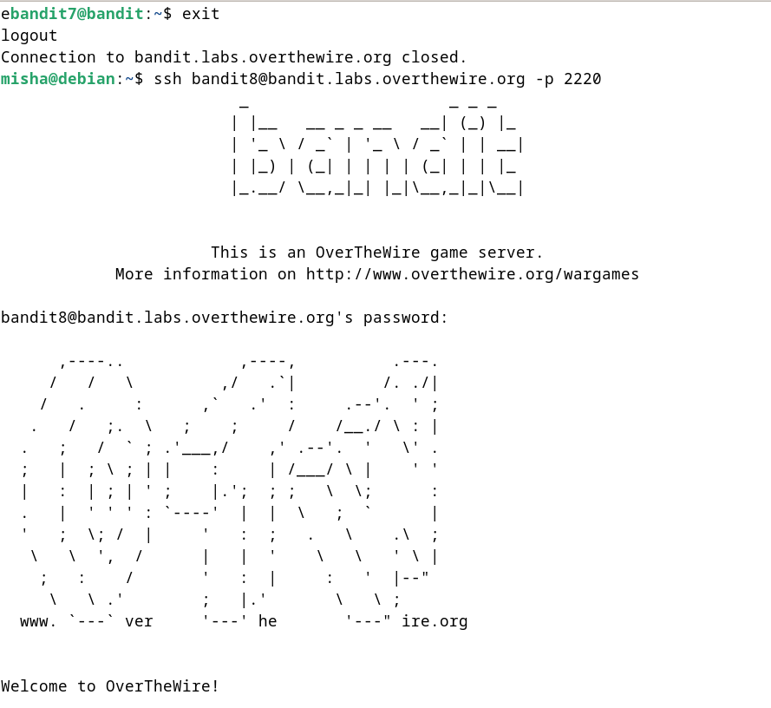

**Lessons Learned:** Level 7 to 8 introduced us to using the grep command to search and extract specific lines from a file based on a keyword. This level also reinforced the use of basic file handling and text processing commands.

**Conclusion:**

Levels 7 to 8 of the OverTheWire Bandit challenge continue to build on shell command knowledge while introducing new challenges involving text processing and searching within files. These levels are suitable for beginners to learn more about file manipulation and data extraction.